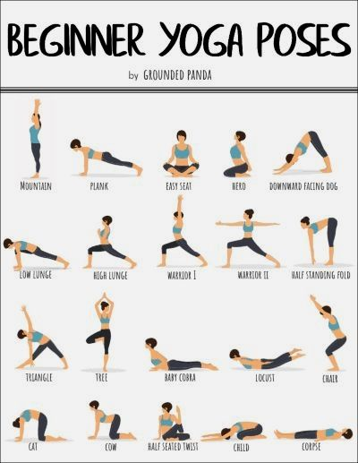

https://www.yogiapproved.com/yoga/standing-beginner-yoga-poses/

