Invente une histoire farfelue!
Voici une image bizarre. Réponds aux questions et invente une histoire d’une demi-page!
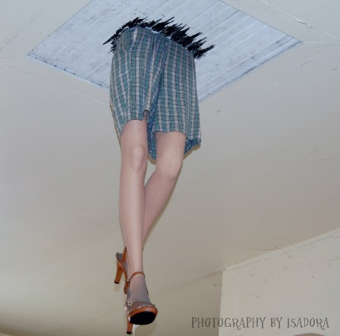
1.Qui est cette personne?
__________________________________________________________________________________
2.Où se passe cette image?
_________________________________________
_________________________________________
3.Quand se passe cette histoire?
_________________________________________
_________________________________________
4.Pourquoi cette personne est-elle là?
_________________________________________
_________________________________________
MON HISTOIRE
____________________________________________________________________________________________________________________________________________________________________________________________________________________________________________________________________________________________________________________________________________________________________________________________________________________________________________________________________________________________________________________________________________________________________________________________________________________________________________________________________________________________________________________________________________________________________________________________________________________________________________________________________________________________________________________________________________________________________________________________________________________________________________________________________________________________________________________________________________________________________________________________________________________________________________________________________________________________________________________________________________________________________________________________

