Read 20 minutes every day!



Writing

This week’s writing genre focuses on opinion writing. See resources and digital lessons below.

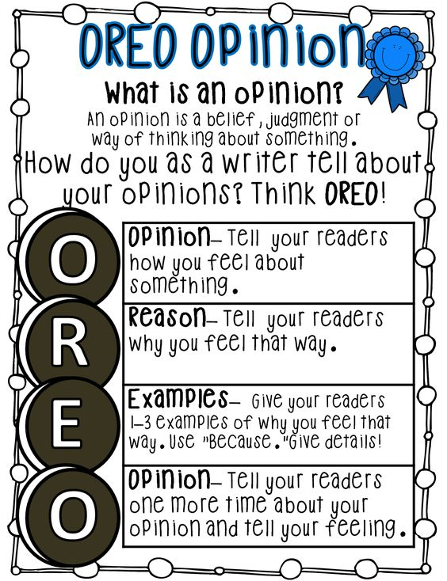

View the following three teaching videos on how to write an opinion piece:

1. Episode 1: What is an opinion piece?

Link: <https://www.youtube.com/watch?v=KEK2oGBSsHk>

1. Episode 2: Choosing an opinion writing topic

Link: <https://www.youtube.com/watch?v=qv4rHG6rrr8>

1. Episode 3: Making an opinion writing plan

Link: <https://www.youtube.com/watch?v=7kYtkqfXMOg>

Now choose an opinion writing topic and print off the graphic organizer below to make your opinion writing plan.

**Opinion Writing Graphic Organizer**

|  |  |
| --- | --- |
| **REASON #1**  **Topic** | **REASON #2** |
| **REASON #3** | **REASON #4** |