Grade 5 Independent Research Mini Project

Starting last fall, as a class, we gathered information about Oceans. We read books, watched videos, and searched the internet for facts and details. After everyone was given a more specific topic about oceans, we made notes from these sources and picked the most important information and started writing a descriptive report in paragraphs. Some even had an illustration(picture), map or chart to label to go with their topic.

Now, you get to choose any topic you are interested in – to learn more about or to share with me if you wish. Once you have gathered all your information, you can choose to share it in a:
- Poster- with a title and labeled facts and details and illustrations (drawings)/graphics (pictures).
- Descriptive report – put all your facts and details in full sentences in 3 paragraphs: an introduction, middle and conclusion.
- Pamphlet – fold your paper in three. The first page is like a title page, the other 5 sides can be filled in with information and graphics.
- Power point – a mix of images and facts/details on 3-5 slides.

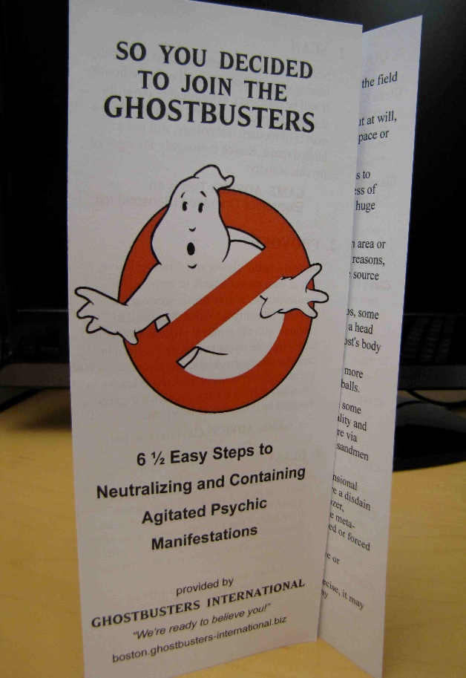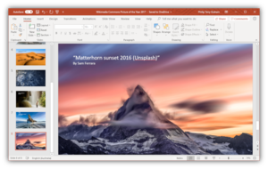
This Photo by Unknown Author is licensed under CC BY-NC-ND
This Photo by Unknown Author is licensed under CC BY-SA
Pamplet power point
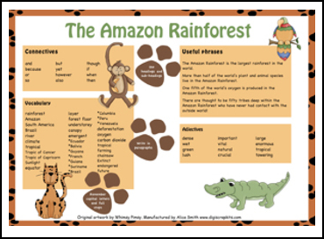Posters
This Photo by Unknown Author is licensed under CC BY-NC-ND

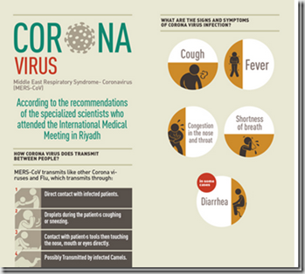
This Photo by Unknown Author is licensed under CC BY-SA-NC

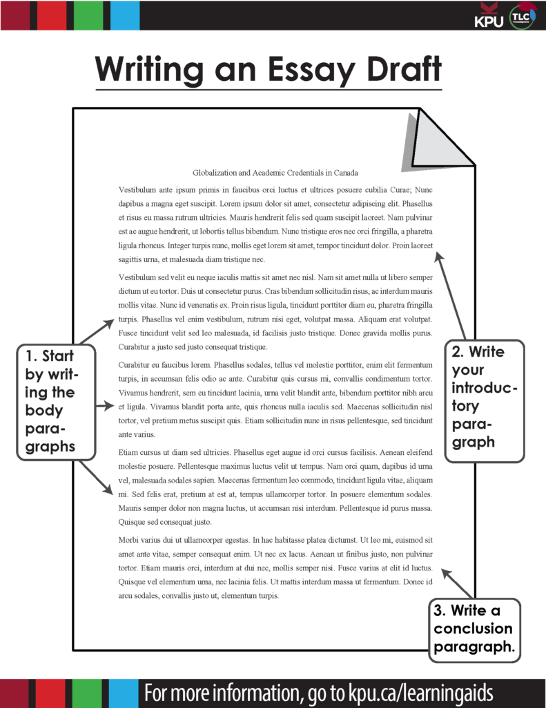 Descriptive report
This Photo by Unknown Author is licensed under CC BY-SA

Once you are finished, ask a parent to take a picture of it (poster/report) and send it to me, or send me your power point to my email: christina.savoy@nbed.nb.ca.

Don’t forget to source your facts/details by listing the URL address of the sites where you got some good information. If you used a book, list the title and author. If you found a great video to help you out, list the title and URL. It is always important to show where you found your information!

Here are some sites from class that may help you out:

1- kidtopia 5. kidrex
2- GoGooligans 6. Fact monster
3- Kiddle 7. cybersleuth
4-kidzsearch

