Grade 8 Health: Diversity
The first half is some notes to help you understand the topic:

Discrimination-the unjust or prejudicial treatment of people or things, especially on the grounds of race, age, or sex.
Ex, people who have disabilities, sexual orientation, gender identify race religion.

Prejudice: preconceived opinion that is not based on reason or actual experience about a group of people.
-Why are some people treated differently than others? (scared, uncomfortable etc.)
-Why do we have these beliefs? (media, fear, family)

Assignment:
Quick paragraph response:
who are the people that you feel face discrimination the most and why?

Read the follow

Star bucks story: See below! After you are done reading write a few sentences to say whether you were surprised or not that she was working for Starbucks and why?

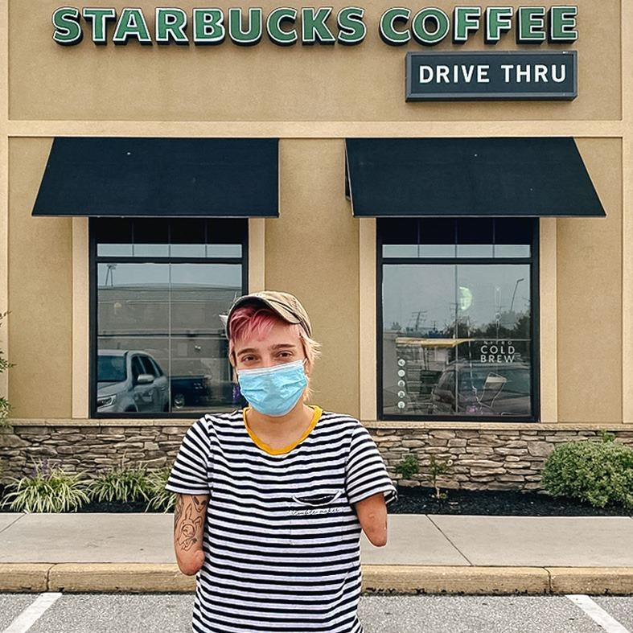

Marina grew up helping on her family farm, playing soccer, running, painting and baking lots of cakes. The fact she was born a congenital quadruple amputee is just one part of her story.
“I’m just trying to get through life the same way everyone else is," says Marina. "If I'm honest, I forget that I'm missing multiple limbs."
Marina chooses to focus on her strengths. This is exactly what she told Paula, a Starbucks store manager, the day she applied for a job. Together, they worked out a plan and Marina is now a barista handling customer service, working the register and brewing coffee. Marina is also finishing her associate and bachelor's degrees and getting her driver's license.
"I’ll never change the fact that I am an amputee. I don’t know any other way of doing anything. I just got to embrace it and go for it and hope for the best.”
To celebrate National Disability Employment Awareness Month and 30 years of the Americans with Disabilities Act we're sharing stories of our partners (employees) like Marina who live with a disability.

