November 12 Lesson
Please read through the following lesson
Stereotypes: Beliefs we have about a certain group of people that may or may not be true.
Example: all blondes are dumb, red heads have bad tempers, all Asians are super smart.
We get these beliefs from our family, friends, and media.

-Talk about human rights: Watch this video to find out:
Watch a video: https://www.youtube.com/watch?v=pRGhrYmUjU4

Everyone has a right to be treated fairly no matter their sex, race or age. Below you will find a list of Human Rights. Please keep in mind as your read them there is a difference between needs and wants.
Needs- What you have to have in order to survive (example) food, water, shelter
Wants- Are things you would like to have, but it’s not important for our survival
(example) Newest game console, cell phone, name brand clothing.

The list below are examples of “Needs”. We needs these things in order to survive.

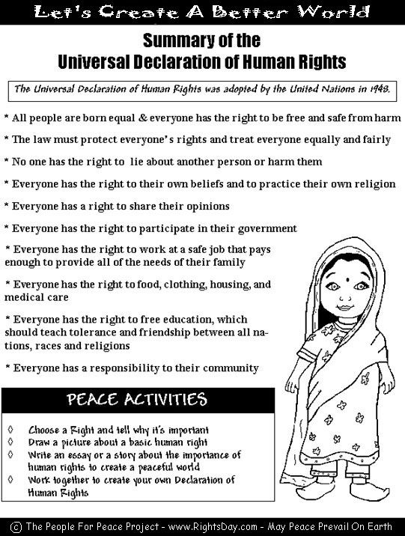

-After reading you are to chose one of the above Rights and tell me why it’s important.

.

