Respect to all people; Grade 7

Hook: compare yourself to someone from another country: Afghanistan. Look up pictures if needed. I have provided an example to help you out.

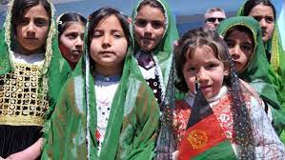

How are people from Afghanistan the same as me | How are we different ?
-we all have families. | -clothing

What does respect mean?
Respect means-due regard for the feelings, wishes, rights, or traditions of others.

-What are the different cultures we see here in Campbellton? Make a list:

Why You Should Experience Other Cultures
- Broaden your perspective of the world.
- Learn a new language.
- Learn new skills.
- Expand your circle of friends all around the world.
- Enhance creativity.

-Video on culture:
https://www.youtube.com/watch?v=RwSYrsjTiW4

