Short story Assignment:
During our short story unit, we have read fictions, myths, legends, mysteries, just to name a few. Now you have an assignment to complete. You are going to choose one of the different short stories we have read and complete the following assignment. See the rubric attached to see how you will be evaluated.

- Choose any 5 of the following words and tell what they mean(define) and give a good example to show your understanding. If you do more than 5, I will only mark the first 5 you do.

Conflict
Plot
Theme
Conflict
Foreshadow
Setting
Protagonist
Antagonist
Rising Action
Climax

- Choose one of the stories we have read and do the following assignments.

- Literal response: Retell the story with good detail. Pretend that I never read the story before. Keep in mind the 5 parts to a short story when retelling it.

- Inferential/interpretive response: Describe how and why the main character changes from the beginning of the story to the end.

- Personal Response: How are you and the main character the same? How are you different? Use a Venn diagram to illustrate your answers. Then respond using a paragraph. I will demonstrate how to do one.

Example of a Venn diagram found on the next page.

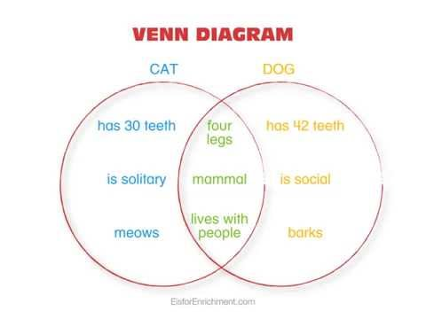

-See the attachment to see how this will be graded. This is due , November 13.

NOTE: Before you hand in your good copy send it my way first for feedback. When you are handing it in, please let me know this is your copy to be marked.

-Please save your work in a new word document.

