Campbellton Middle School
Extracurricular School Sports 2017-18

Dear Parents/Guardians:

We would like you to know that our school offers sports for students who wish to take part. There are two options for participation: noon-hour intramurals and extramural sports. In order to assist you in determining which program(s) would be most suitable for your child, the differences are outlined below. Should you choose to allow your child to participate in the extracurricular sports program, please sign the bottom of the next page and ask your child to return it to the school as soon as possible.

 | Noon-hour intramurals  (12:25pm – 12:55pm) | Extracurricular Sports Teams (Cougars and Lady Cougars)  (after school and/or on weekends)
Coaches / Supervisors | Staff members | Volunteers from the school and our local community.
Competitiveness | Recreational | Semi-competitive to competitive
Cost to participate | None, included in $25 student fee | $20 per sport (on top of student fee), which helps our school to defray costs associated with the team. These costs may include officials, tournament fees, jersey renewal, equipment, Celebration of Sports evening, etc. This fee is due prior to receiving jersey and/or playing the first game.  Parents/guardians experiencing financial hardship are encouraged to contact the school at 789-2120.
Eligibility | Please note that a few of the sports may be limited to certain grades.  Students in good behavioural standing may participate in intramural sports. | Please note that a few of the sports teams or game play may be limited to grades 6-8.  Students in good behavioural standing may participate extracurricular sports teams.
Jerseys | None needed or assigned | Assigned. Students are responsible for handing in their assigned jerseys at the end of the season. If lost or intentionally damaged, replacement costs are a maximum of $75.
Playing time | Fairly equal | Not always equal. During the regular season, all players will get some playing time. However, during tournaments, some athletes may get very little or no playing time. Coaches may determine playing time based on a number of factors such as attendance at practices, skill level, sportsmanship (respect, attitude, being a team player), behavioral standing, team needs, etc.
Practices | None | Mandatory and regular (after 3:30pm and/or on weekends)
Sports options | Usually include softball, soccer, floor hockey, other gym activities | Usually include soccer, basketball and volleyball
Transportation | none needed | Please note that the school does not arrange for transportation. It is the responsibility of parents/guardians to make their own arrangements to get their children to and from practices, games and tournaments.
Tryouts | None | There will be tryouts, as spots on the team may be limited.

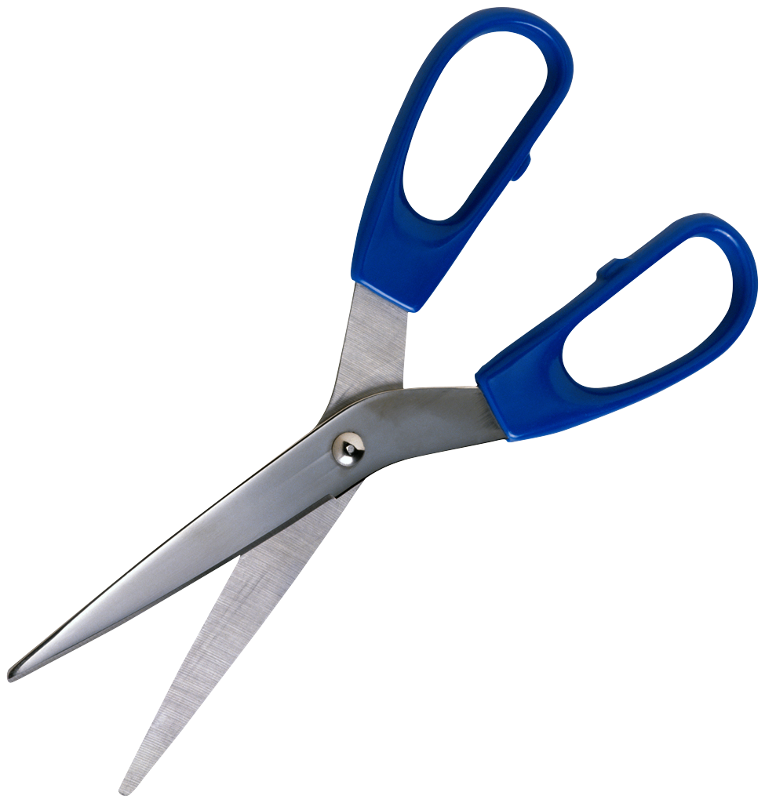

-------------------------------------------------------------------------------------------------------------------------------------

Campbellton Middle School
Extracurricular School Sports 2017-18

I have read the information provided about extracurricular sports at CMS. I understand that because this is a semi-competitive program, my child may not have equal playing time. I also understand that my child will have to…
- Maintain good behavioural standing
- pay a sports fee of $20 per sport
- maintain their assigned jersey in good condition and return it at the end of the season
- attend practices/games on a regular basis
- find his/her own way to and from practices, games and tournaments.

I (circle one) DO DO NOT give permission for my child to participate in a CMS extramural
sports team(s) during the 2017-18 school year.

Student name: ________________________________________ | Date: ______________________________________________________
Parent/Guardian name: _____________________________ | Parent/Guardian Signature _____________________________

